Line Following Robot Car Project
/179 Marks
OBJECTIVE
Build a line following Robot car and compete in the annual C.A.S.T Robot Race.
Background
The Arduino line follower robot can be divided into 4 sections (see figure 1): power section (red), sensor section (blue), control section (yellow) and driver section (green).
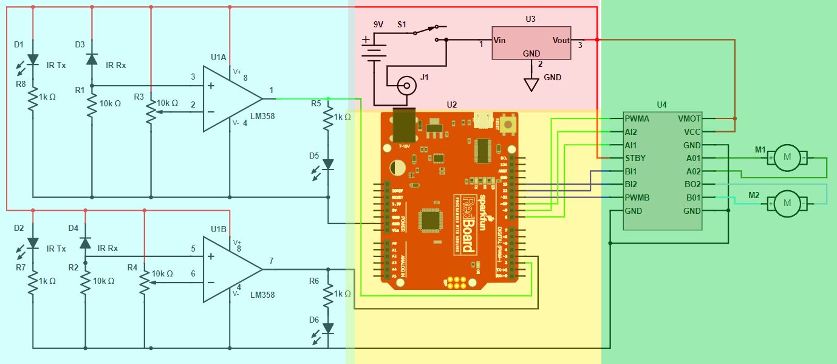
Figure 1: Line Following Robot Car Sections
Power Section:
This section uses a L7805 voltage regulator to convert the voltage from a 9-volt battery to the 5 volts needed to run the Arduino, motors, and motor driver.
Sensor Section:
This section contains the following: two Inferred (IR) diodes, one that transmits IR light (IR Tx) and one that receives IR light (IR Rx), potentiometer, Comparator (LM 358 Op-Amp) and LEDs.
The potentiometer is used to set reference voltage at the comparator's inverting terminal. Next, IR sensors are used to sense the line and provide a change in voltage at the comparator's second terminal. Then the comparator compares both voltages and generates a digital signal at the output.
The IR diodes are used to create a proximity sensor. A proximity sensor is a sensor able to detect the presence of nearby objects without any physical contact. A proximity sensor often emits an electromagnetic field or a beam of electromagnetic radiation (infrared light) and looks for changes in the field or return signal.
When light falls on a white surface (The background color of the track), the IR receiver almost entirely reflects, producing a higher voltage at the IR Rx. Conversely, light is completely absorbed on a black surface (the colour of the line that will be followed), producing a lower voltage at the IR Rx. This behaviour is how the robot will detect the line's location.
Control Section:
An Arduino Uno R3 is used to control the robot. First, the Arduino will read the voltage outputted by the op-amp. Then, based on those readings, the Arduino will output the required voltages to control the motor driver.
Driver Section:
The driver section consists of a Dual H-bridge TB6612FNG motor driver and two 4.5-volt DC motors. The H-bridge motor drivers will control the rotation direction of each wheel. In contrast, the speed of each wheel is controlled by a pulse-width modulated signal injected into the motor driver by the Arduino.
Concept of How the Robot Works
The IR sensor will detect the location of the line by sensing the change in color from white to black.
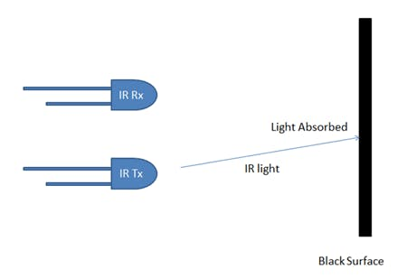
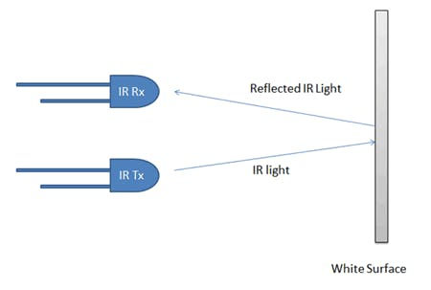
Figure 2: IR Sensors
Next, an LM358 op-amp is used to compare the voltage from the IR Rx diodes to a reference voltage set using a potentiometer. When the reference voltage is greater than the IR Rx voltage, the output of the op-amp is HIGH (5-volts). When the reference voltage is lower than the IR Rx voltage, the op-amp output is LOW (0-volts). Arduino drives the motor according to the op-amps outputs. When both left and right sensor senses white then robot move forward.
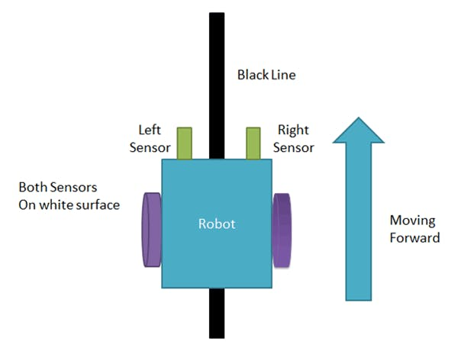
Figure 3: Robot Moving Forward
If left sensor comes on black line, then robot turn left side. It will do this by reversing the rotation of the left motor and increasing that motors speed.
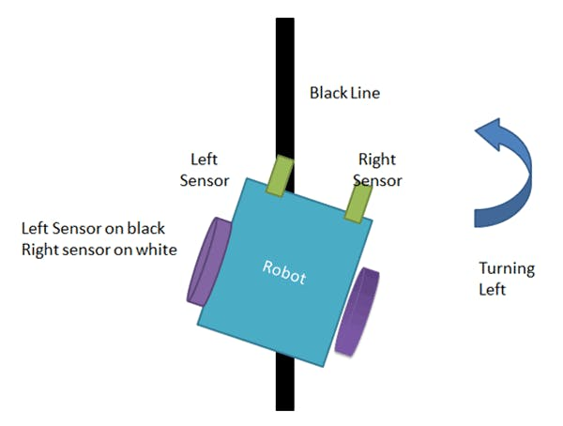
Figure 4: Robot Turning Left
If right sensor sense black line, then robot turn right side until each sensor comes at white surface. When white surface comes robot starts moving on forward again.
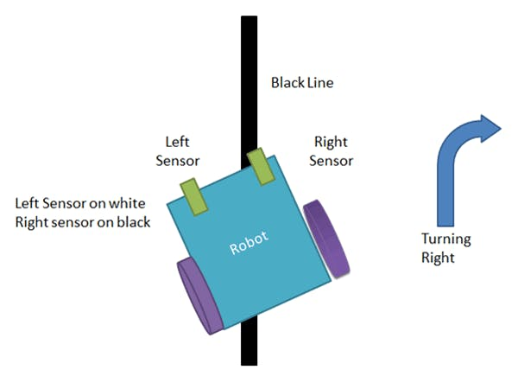
Figure 5: Robot Turning Right

If both sensors come on black line, robot stops.
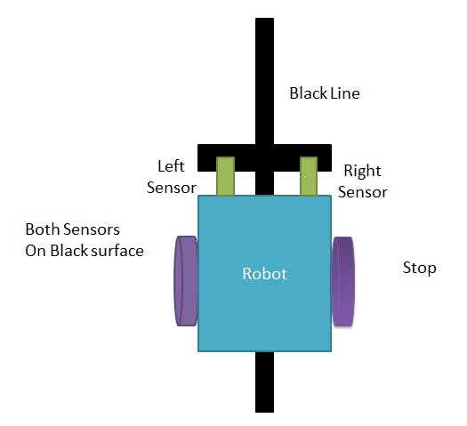
Figure 6: Robot Stops

EQUIPMENT
From the Electronic Components Fun Kit:
- Female Pin Header x 1
- Male Pin Header x 1
- Toggle Switch x1
- 9V Battery Clip Connector x 1
- 1k Ω Resistor x 4
- 10k Ω Resistor x 2
- LED Red x 2
- Jumper Wires (as needed)
From Spark Fun Inventors Kit (Version 4.1):
- Arduino Uno x 1
- 4.5VDC Motor x 2
- Motor Driver (Dual TB6612FNG v2) x 1
- Wheels x 2
From Addition Components Kit:
- 10k Ω Potentiometer (‎5046XIB18ZTY) x 2
- Caster Wheel (27032021080401) x 1
- Arduino Uno R3 Prototype PCB Shield Board (‎PCB-D243-10) x 1
- 5mm Pair 940nm Infrared Diode LED Emission and Receiver x 2
- LM385p Op-amp x1
- 8-pin IC Socket x 1
- L7805EV Voltage Regulator x 1
- Black paper x 1
- White paper x 1
Bench Equipment:
- DC Power Supply x1
- DMM x 2
- Breadboard x1
- PC with an internet connection x1
- USB cable for Arduino x 1
PROCEDURE
Phase 1- Prototyping and Testing
Section 1: Powering the Robot
- Start by installing the L7805 voltage regulator into the bread board.

Instructor Tip: The leads of the L7805 are a bit to large to fit into the holes in the beadboard. Soldering 22 AWG wires to the leads of the L7805 will solve this problem (see figure 7).

- 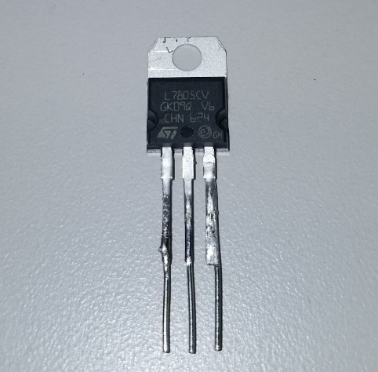
Figure 7: L7805 with 22 AWG Wire Legs.

- Using the schematic in figure 8, connect the L7805 to the beadboard and the bench power supply. When you have completed the build of the circuit, perform the following measurements to verify that the L7805 is working correctly. Record the data collected into Table 1.

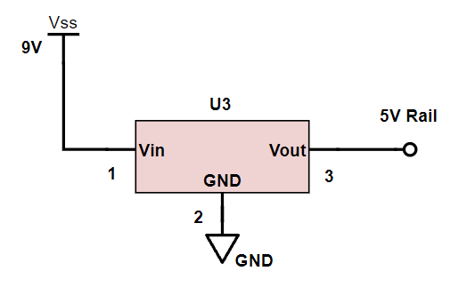
Figure 8: L7805 Schematic

Voltage for L7805 | Voltage
Pin 1 – Pin 2
Pin 1 – Pin 3
Pin 3 – Pin 2
Table 1: Voltage measurements of L7805 / 3 Marks

- Connect pin 3 of the L7805 to the power rails on the top and bottom of the breadboard. Then connect the ground pin of the L7805 to the top and bottom ground rails of the beard board. This will be used to supply power to the rest of the components.
Section 2A: Infrared Sensors
The line following robot uses two different LEDs to detect the difference between a white and black surface (you can think of the IR sensors as the eyes of the car). An example of a pair of IR LEDs can be seen in figure 9.

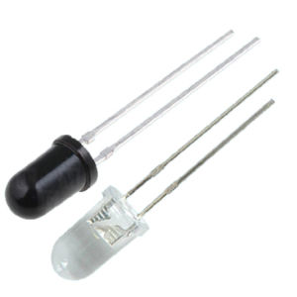
Figure 9: IR LEDs
Note: Tx LED is clear, and the Rx LED is black.
- Build the circuit shown in figure 10. Pay close attention to the polarity of the LEDs. Installing the Tx and Rx LEDs close together will improve the acracies of the detectors.

Instructor Tip: Connecting one pair of IR LEDs two each power rail and at the far end of the board will make it easier to test them later.

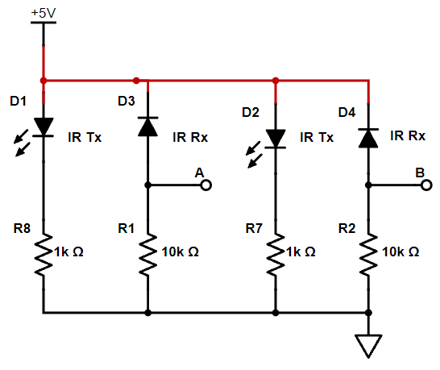
Figure 10: IR LED Schematic

- Measure and record the voltages in Table 2. Make sure to not cover the LEDs when you are taking your measurements.

Voltage at the cathode of D1
Voltage at the cathode of D2
Voltage at the anode of D3
Voltage at the anode of D4
Table 2: IR LED Voltage Measurements / 4 Marks

- Place a black piece of paper over both IR LEDs them measure and record the voltage in Table 3.
- Repeat the task from step 6 but this time use a white piece of paper.
Voltage at point A with black paper.
Voltage at point B with black paper.
Voltage at point A with white paper.
Voltage at point B with white paper.
Table 3: IR LED Voltage Measurements Part 2 / 4 Marks
- Describe the change in voltage measured at point A and B when the two different colors of paper are covering the IR LEDs and how this confirms that the IR LEDs are working correctly? / 4 Marks.
Enter Text
- Why is the Rx LED installed backwards (reversed bias)? / 5 Marks.
Enter Text
Section 2B: Comparator
The purpose of this section of the circuit is as follows: the voltage at the anode of the IR Rx diode will change depending on the amount of light it detects. The op-amp will compare the IR Rx voltage to a reference voltage that will be supplied by a potentiometer connected as a voltage divider. If the voltage of the IR sensor is higher then the reference voltage, the output of the op-amp will be HIGH (5V or a digital 1). If the voltage of the IR sensor is lower then the reference voltage, the output of the op-amp will be a LOW (0V or digital 0).
You will be using a LM358 dual op-amp as a comparator (see datasheet here). The voltage from the anode of the IR Rx diode will be connected to the negative input of the op-amp. A potentiometer connected to the positive input of the op-amp will be used as a voltage divider to set the referenced voltage for the comparator. The outputs of the op-amp will be connected to a microcontroller that will use these signals to control the operation of the motor driver and as a result the motion of the robot.

Connect the LM385 to the IR sensor circuit that you built in section 2. Use the schematic in figure 11 as a reference.
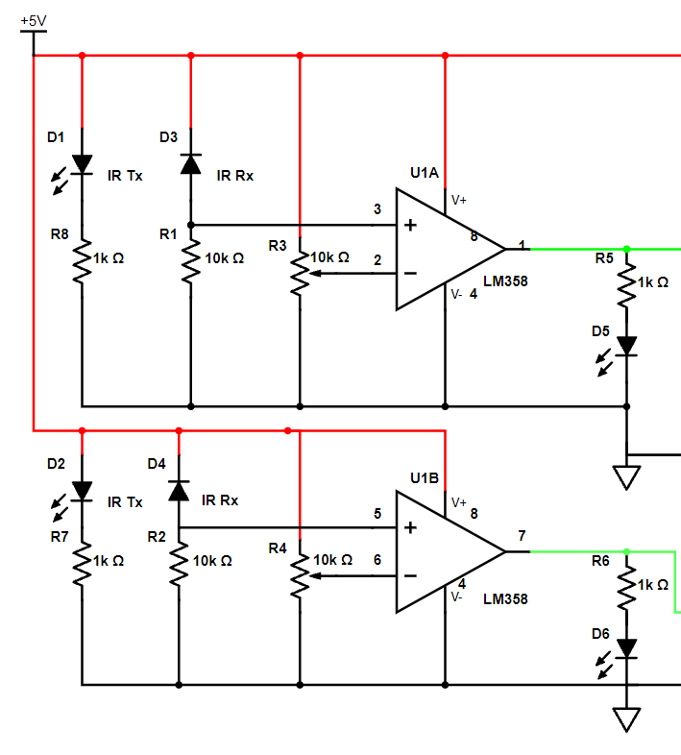
Figure 11: Op-amp Schematic
- With circuit complete turn both potentiometers fully CCW, then apply power and measure the voltage at each pin on the LM358 and record them in table 4.
Pin Name | 1 | 2 | 3 | 4 | 5 | 6 | 7 | 8
Voltage
Table 4: Op-amp Voltage / 8 Marks
- Now you will need to calibrate the op-amp. Connect the DMM to pin 2 and adjust R3 until the DMM reads 700mV. Use a white piece of paper with a 10 cm black line in the center test the operation of the circuit. Place the paper on top of the IR LEDs. Move the paper back and forth so both the white and black parts of the paper are above the IR sensor.
- Repeat the calibration process for pin 6, R4, and the other IR sensor.

Section 3: Motors and Motor Driver
The motors will need to perform the following actions for the robot to work correctly:
- Move forward in a straight line (Both motors spin at the same speed).
- Turn left (The left wheel spins slower than the right wheel).
- Turn Right (The right wheel spins slower than the left wheel).
- Stop (Both wheels do not spin).
The simplest way the get the motors to perform these actions will be to connect them to a motor driver. For this build you will be using a Dual TB6612FNG motor driver. This motors driver uses pulse with modulation (PWM) to control the speed of the motors and 4 MOSFETS (2 NPN MOSFETS and 2 PNP MOSFETS).
You can see how the H-bridge circuits work by clicking on the following link. https://tinyurl.com/yg9xh7yo
Note: You never want to have both switches in the same position (example: switch 1 = 5V, and switch 2 = 5V).
- When the switch on the left is connected to 5V and the switch on the right is connected to ground, would the motor be spinning clockwise (CW) or contraclockwise (CCW)
Enter Text / 1 Mark

- If both switches are flipped, which way will the motor spin?
Enter Text / 1 Mark
- Using the circuit shown in figure 12, connect the TB6612FNG and the motors to 5V DC and the function generator.
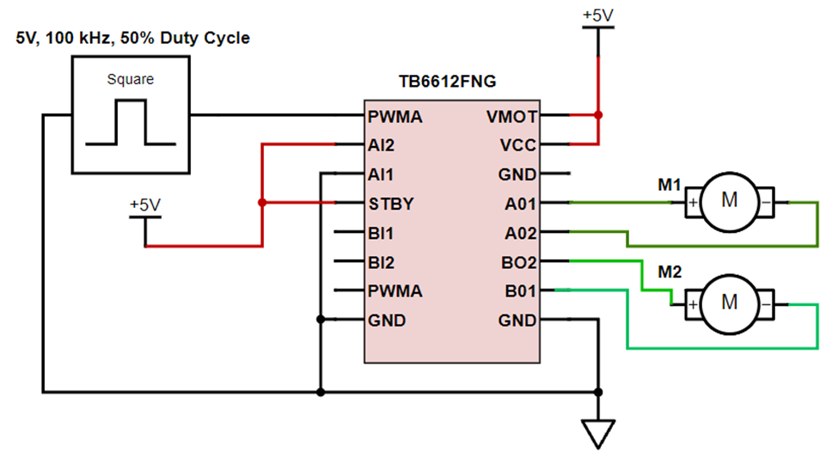
Figure 12: TB6612FNG Schematic

- With the circuit connected, one wheel should be turning. Which wheel is turning? (M1 or M2) Enter Text / 1 Mark

- Which way is it turning CW or CCW?
Enter Text / 1 Mark

- Connect an oscilloscope to the PWMA pin so you can see the waveform. Save the image of the wave form and copy it into the section below. / 1 Marks.
How to copy image from oscilloscope:
- Insert a USB flash drive into the USB port below the screen on the scope (use the one for the 3D printers). “USB flash drive detected” will appear on the screen.
- Press the “Save” button then the “Type” button.
- Using the Intensity adjustment wheel highlight .JPG as the type then press the intensity adjustment wheel in to make the selection.
- Press the “press to save” button twice. A message will appear on screen confirming the file ha been saved.
Copy image of 50% Duty Cycle Here >

- Increase the duty cycle on the function generator to 99%. How dose this effect the spinning of the wheel?
Enter Text /1 Mark

- Save the image of the wave form and copy it into the section below. / 1 Marks
Copy image of 99% Duty Cycle Here >

- Make sure that AI2 is connected to 5V and AI1 is connected to GND. Adjust the duty cycle to the following values and measurements and record the VDC of the PWAMA pin in Table 4.
AI2 = 5V, AI1 = GND | PWMA Pin VDC
Duty Cycle 50%
Duty Cycle 70%
Duty Cycle 90%
Table 4: Duty Cycle effect on DC Voltage /3 Marks

- Connect AI2 to GND and AI1 to 5V, then adjust the duty cycle to the following values and measurements and record the VDC of the PWAMA pin in Table 5.

AI2 = GND, AI1 = 5V | PWMA Pin VDC
Duty Cycle 50%
Duty Cycle 70%
Duty Cycle 90%
Table 5: Duty Cycle effect on DC Voltage /3 Marks

- How does changing the voltage values of AI2 and AI1 effect the operation of the wheels?
Enter Text / 1 Mark
- Verify that the other side of the motor driver is working correctly by connecting the faction generator to the B side of the motor driver as seen in figure 13.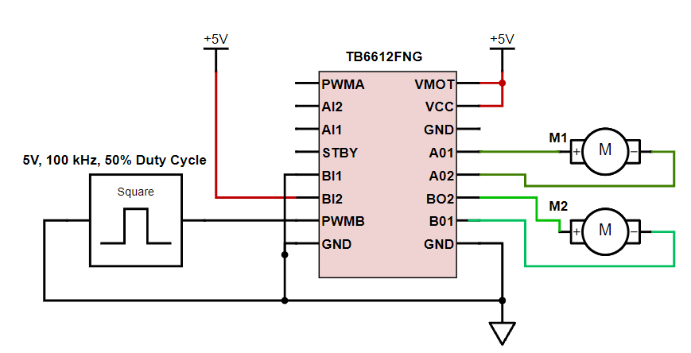
Figure 13: TB6612FNG Schematic B Side
Note: The negative of the motor should go to pin A02 and B02

- Complete and record the measurements in Table 6.
BI2 = 5V, BI1 = GND | PWMB Pin VDC
Duty Cycle 50%
Duty Cycle 70%
Duty Cycle 90%
Table 6: Duty Cycle effect on DC Voltage /3 Marks

- Connect BI2 to GND and BI1 to 5V, then complete and record the measurements in Table 7.
BI2 = GND, BI1 = 5V | PWMB Pin VDC
Duty Cycle 50%
Duty Cycle 70%
Duty Cycle 90%
Table 7: Duty Cycle effect on DC Voltage /3 Marks
- Set the frequency of the function generator to 50k Hz. What affect did this have on the speed or direction of the wheel rotation? / 2 Marks
Enter Text
- If the A motor is on the left side of the robot and the B motor is on the right, what combination of HIGH(H), LOW(L) and speed adjustment (50% duty cycle or 90% duty cycle) will be needed to achieve each specific robot movement in Table 8.
Hint: the answer can be found in the code.

AI1 | AI2 | BI1 | BI2 | PWMA Duty Cycle % | PWMA Duty Cycle % | Robot Movement
H | L | H | L | 90% | 50% | Turn Left
 |  |  |  |  |  | Turn Right
 |  |  |  |  |  | Straight forward
 |  |  |  |  |  | Stop
Table 8: Robot Movement Pin Code /24 Marks

Section 4: Connecting the Microcontroller
The microcontroller that we will be using is the Arduino Uno R3. The prepose of the microcontroller is to receive the output voltage from the LM 358 op-amp. Based on that data, apply the correct voltages to the motor drive to propel the car in the correct direction and speed.
- Using the link provided here, download and install the Arduino IDE on your PC.
- Download the .ino file named Line_Follower_v2 found in the reference section of the Shop-144 D2L page.
- Open the Arduino IED and click File > Open > select the .ino file from the download location.
- Next open the tool menu in the Arduino IED and select Tool> Port. Select the port that the Arduino is connected to.
- Upload the code to the Arduino by pressing the Upload icon in found near the top left of the Arduino IED (see figure 14).

Figure 14: Arduino Upload Icon

- Connect the Arduino Uno to the circuit using figure 15 as a reference.
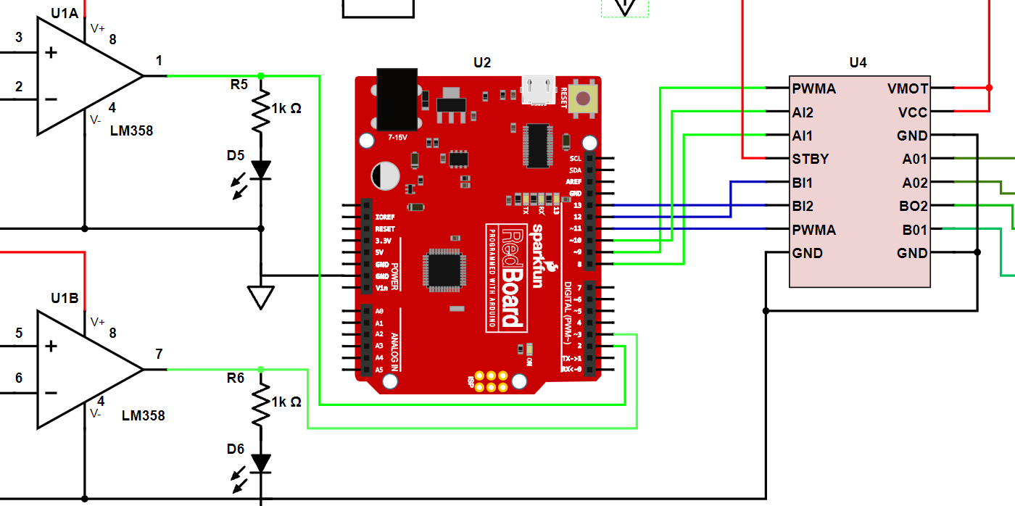
Figure 15: Arduino Wiring Diagram
- Using a 9-volt battery to power the Arduino, test and verify the circuit is working correctly.
- Demonstrate the working circuit for you instructor. Be prepared to explain how the circuit functions. / 20 Marks
Phase 2- Fabricating a PCB
Using an Arduino Uno R3 Prototype PCB Shield Board (see figure 16) fabricate a shield that will connect the electronic circuit to the Arduino. It will be up to the student to design the layout for the components. Header pins will be used to connect the PCB to the Arduino. The IR sensors will also be contested to the PCB with header pins connected by jumper wires.
Component Layout: / 20 Marks
- Minimal wires overlapping.
- Components must be in the proper orientation to the board (vertical and straight).
- The PCD must fit correctly to the Arduino (flat and tight with no gaps).
Soldering: / 40 Marks
- No cold solder joints.
- No excess solder on the joints
- Flux must be cleaned from solder joints and the PCB.

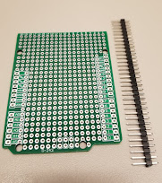
Figure 16: Arduino Uno R3 Prototype PCB Shield Board

Phase 3- Design and 3D print a Chasse for the Car. /10 Marks
- Design a chasse that all the necessary components can be mounted too.
- Components must be secured to the chasse (by screws or friction fit).
- The length and width of the chases can not exceed 150 mm x 150 mm.
- The total wight of the chases can not exceed 50 grams.
- Wheels and motors must be located near the rear of the chasses and the IR sensors must be located near the front.
- MAKE IT LOOK COOL.

- Verify that all components of the car are working correctly by completing one lab of the racetrack. Have you instructor verified the time that your car takes to complete the Track.
First Lap Time: Click or tap here to enter text. /5 Marks.
Instructor Initials: Click or tap here to enter text.

Phase 4 – Make Improvements /10 Marks
Find and implement a solution(s) that will improve the cars preferments. All race rules must still be followed.

Race Rules:
- Car must be powered by one 9-volt battery only.
- The chasse of the car must not exceed a length and height of 150mm x 150 mm.
- The chasses (without components) must not exceed 50 grams.
- The car must be self propelled.

